SOFTWARE REQUIREMENTS SPECIFICATION

**For**

**Online Survey System**

**Prepared by:-**

*Krishna Paresh Raichura*

*Subashini.M*

*Sreejha.J*

# Introduction

## Purpose

## The purpose of the online survey system is to provide a user-friendly and efficient platform for conducting surveys and gathering valuable insights from participants. This system aims to streamline the survey creation, distribution, and analysis processes, facilitating the collection of diverse data sets for various purposes. Whether used for academic research, market analysis, or internal feedback, the survey system intends to offer a robust and customizable solution to meet the unique requirements of users. Through intuitive interfaces and advanced features, the system seeks to enhance the overall survey experience for both administrators and respondents. By automating key aspects of the survey lifecycle, such as result aggregation and report generation, the system aims to save time and resources, allowing users to focus on deriving meaningful conclusions from the collected data.

## Document Conventions

* + - Entire document should be justified.
    - Convention for Main title

Font face: Times New Roman Font style: Bold

Font Size: 14

* + - Convention for Sub title

Font face: Times New Roman Font style: Bold

Font Size: 12

* + - Convention for body

Font face: Times New Roman Font Size: 12

## Scope of Development Project

The Online Survey System is a cutting-edge internet-based application designed to revolutionize the survey process. Tailored for administrators and participants, this system redefines user experiences by offering a dynamic interface for seamless survey creation, distribution, and analysis. The primary objective is to enhance the efficiency and accessibility of surveys across various domains, from academic research to market analysis. With a focus on user-centric design, robust data management, and advanced analysis tools, the Online Survey System aims to provide a versatile and reliable platform for collecting and interpreting valuable insights.

The Online Survey System is a scalable and adaptable platform prioritizing data security through encryption, legal compliance, and privacy standards. Administrators benefit from efficient tools, real-time monitoring, and live editing, supported by comprehensive user assistance. Built in Java for performance and cross-platform compatibility, this system is a reliable and flexible solution for diverse survey requirements, ensuring a smooth experience for both administrators and participants.

## Definitions, Acronyms and Abbreviations

JAVA -> platform independence SQL-> Structured query Language ER-> Entity Relationship

UML -> Unified Modeling Language

IDE-> Integrated Development Environment SRS-> Software Requirement Specification

## References

* + - Books

 Software Requirements and Specifications: A Lexicon of Practice, Principles and Prejudices (ACM Press) by Michael Jackson

Software Requirements (Microsoft) Second EditionBy Karl E. Wiegers

Software Engineering: A Practitioner’s Approach Fifth Edition By Roger S. Pressman

* + - Websites

[**http://www.slideshare.net/**](http://www.slideshare.net/)

[**http://ebookily.net/doc/srs-online-survey-system**](http://ebookily.net/doc/srs-online-survey-system)

# Overall Descriptions

## Product Perspective

Use Case Diagram of Online Survey System

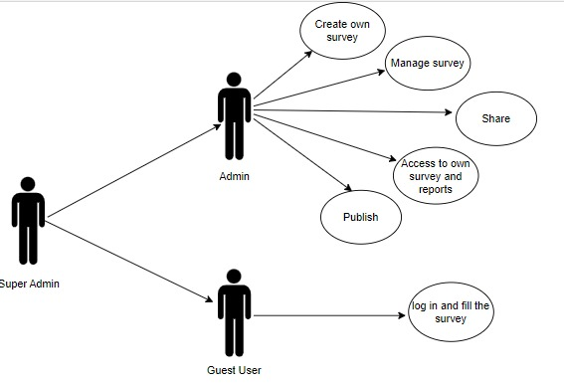

The Online Survey System is a standalone web application for comprehensive survey management. It operates independently with integrated modules, ensuring secure data handling and compliance. It's flexible, allowing API integration with external systems, and emphasizes scalability. The user-centric design facilitates easy survey creation, distribution, and analysis, making it suitable for diverse contexts from academic research to market analysis.

## Product Function

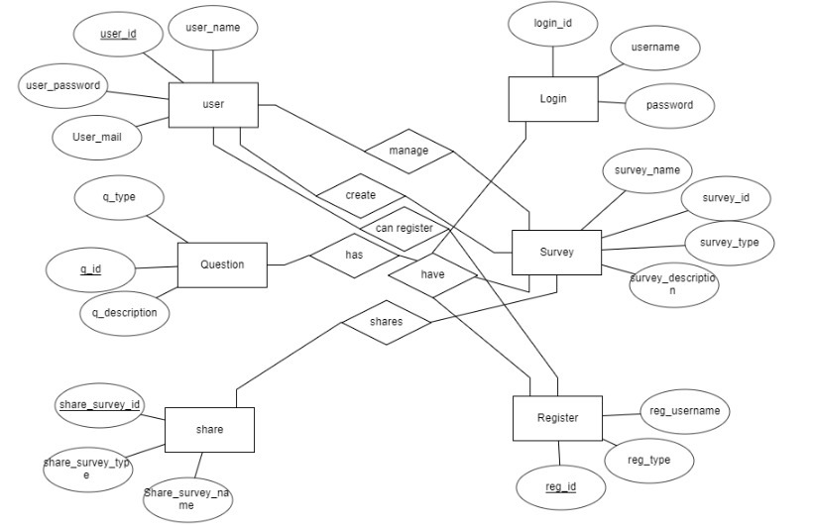Entity Relationship Diagram of Online Survey System

The Online Survey System provides a comprehensive and user-friendly survey management experience. It includes a versatile Survey Creation Module for diverse question types, a Distribution and Participation Module for streamlined engagement, and a secure Data Collection and Storage Module. The intuitive interface allows real-time monitoring and edits, while advanced analysis tools empower administrators to derive meaningful insights. The scalable architecture adapts to varying survey loads, and API integration enhances collaboration with external tools. Overall, it excels in catering to the entire survey lifecycle, ensuring a versatile and efficient platform for diverse survey needs.

## User Classes and Characteristics

The system provides different types of services based on the type of users [Admin/Guest User]. The Super-admin will be acting as the controller and he will have all the privileges of an administrator. The member can be either a student or guest-user of who will be accessing the Survey form and report.

The features that are available to the Administrators are:-

* + - Administrators can create and design surveys with various question types and customization options..
    - They have the capability to edit live surveys in real-time, ensuring flexibility.
    - Administrators can monitor survey progress through a dynamic dashboard.
    - Advanced tools for data analysis, including filtering options and visualizations, are accessible.
    - The system allows administrators to generate comprehensive reports and export raw data.
    - Security features, such as encryption and compliance with privacy standards, are under the control of administrators.

The features that are available to the Survey Participants are:-

* + - Survey Participants can easily access and engage with surveys through a user-friendly interface.
    - They have the ability to view different survey categories and lists of available surveys.
    - Participants can register and authenticate their accounts for personalized survey experiences.
    - Survey Participants can view a history of surveys they have completed and those currently available.
    - The system allows participants to search for specific surveys based on criteria.
    - Accessibility features are incorporated to ensure an inclusive experience for all participants.
    - Participants can provide feedback on their survey experience and suggest improvements.

## Operating Environment

The product will be operating in windows environment. The Online Survey System is designed for Windows compatibility, supporting popular browsers like Google Chrome, Mozilla Firefox, and Microsoft Internet Explorer (versions 6.0 and higher). It requires a basic internet connection and operates optimally with hardware such as a 40 GB Hard Disk, 15” color monitor, and standard keyboard. This ensures accessibility across various devices and configurations, promoting a seamless user experience with an emphasis on compatibility and straightforward hardware requirements.

## Assumptions and Dependencies

The assumptions are:-

* + - The coding of the Online Survey System will be error-free to ensure optimal functionality.
    - The system will prioritize user-friendliness, providing an intuitive interface for easy user navigation.
    - All user, survey, and response information will be securely stored in an accessible database.
    - The system will have ample storage capacity and offer fast access to support efficient database transactions.
    - Robust search capabilities will be integrated into the system for quick data retrieval.
    - The Online Survey System will operate 24 hours a day to accommodate users across different time zones.
    - Users can access the system from any computer with internet browsing capabilities and an internet connection.
    - User authentication, requiring correct usernames and passwords, will be a prerequisite for system access and actions.

The dependencies are:-

* + - The system's functionality depends on specific hardware and software configurations for seamless operation.
    - Development and implementation will be based on the listed requirements and specifications.
    - End users, particularly administrators, must have a thorough understanding of the Online Survey System for effective utilization.
    - The system relies on the proper storage and retrieval of general reports.
    - All user information must be accurately stored in a database accessible by the Online Survey System.
    - Any updates or modifications to survey data will be recorded in the database, requiring accurate data entry practices.

## Requirement

Software Configuration:-

This software package is developed using java as front end which is supported by sun micro system. Microsoft SQL Server as the back end to store the database.

Operating System: Windows NT, windows 98, Windows XP Language: Java Runtime Environment, Net beans 7.0.1 (front end) Database: MS SQL Server (back end)

Hardware Configuration:- Processor: Pentium(R)Dual-core CPU Hard Disk: 40GB

RAM: 256 MB or more

## Data Requirement

The Online Survey System operates on a query-driven model, where users input requests for actions such as creating surveys, customizing questions, and submitting responses. Survey administrators initiate queries for survey management, while participants input responses to survey questions. Outputs include solutions to user queries, providing details such as survey analytics, participation history, and account information. For example, administrators receive outputs confirming successful survey creation, while participants obtain details on their survey completion history and relevant insights. This dynamic interaction ensures accurate and timely data processing, contributing to the seamless functionality of the system.

# External Interface Requirement

## GUI

The GUI of the Online Survey System is thoughtfully designed to offer a seamless experience for both administrators and participants.

* + - Intuitive interface for admins: survey creation, updates, and result viewing.
    - Quick reports, like survey participation within specific time frames, are easily accessible.
    - The system supports stock verification and efficient search functionality based on diverse criteria.
    - Notably, administrators have the flexibility to customize the user interface according to their preferences.
    - All modules seamlessly integrate into the GUI, adhering to defined standards and following a user-friendly template.

Login Interface:-

The login interface ensures a secure entry point, allowing users to register and create accounts, subsequently logging in with their credentials. Error prompts appear for incorrect login attempts, enhancing security.

Search:-

The search functionality enables members and administrators to find specific surveys efficiently by entering relevant keywords.

Categories View:-

The Categories View section displays available survey categories, empowering administrators to manage categories by adding, editing, or deleting them.

# System Features

* The Online Survey System offers a comprehensive and user-friendly platform with secure authentication, diverse survey creation, and a centralized question library.
* It supports various distribution channels, real-time reporting, and data export, ensuring flexibility.
* Advanced features like multilingual support, custom branding, and role-based access control enhance user experience and security.
* The system is versatile with features like survey scheduling, versioning, and analytics for meaningful insights.
* It maintains high accessibility and functionality with mobile responsiveness, participant feedback, and integration capabilities.

# Other Non-functional Requirements

## Performance Requirement

The Online Survey System, intended as the primary platform across university campuses, necessitates robust performance capabilities aligned with university specifications. Key performance requirements include:

* + - The performance of the system should be fast and accurate
    - Integrated robust error handling prevents data loss, includes inbuilt testing for prompt identification and resolution, ensuring reliability.
    - Engineered for seamless handling of extensive data volumes, ensuring faultless performance with large surveys, responses and users.

## Safety Requirement

In developing the Online Survey System, paramount safety measures include a robust backup system to mitigate data loss risks from database crashes. Automated backups and power supply solutions ensure system integrity and availability, fostering a secure and resilient environment for users.

## Security Requirement

## Ensuring the robust security of the Online Survey System is imperative to safeguard sensitive information and maintain the integrity of user accounts. The following security measures are integrated into the system:

* + - System will use secured database
    - Normal users can just read information but they cannot edit or modify anything except their personal and some other information.
    - System will have different types of users and every user has access constraints
    - Proper user authentication should be provided
    - No one should be able to hack users’ password
    - There should be separate accounts for admin and members such that no member can access the database and only admin has the rights to update the database.

## Requirement attributes

* + - There may be multiple admins creating the project, all of them will have the right to create changes to the system. But the members or other users cannot do changes
    - The project should be open source
    - The Quality of the database is maintained in such a way so that it can be very user friendly to all the users of the database
    - The user be able to easily download and install the system

## Business Rules

Adherence to established business rules is crucial in the Online Survey System. Users, including administrators and members, must comply with regulations regarding roles, data handling, and conduct. Transparent pricing and discount policies, along with strict prohibition of illegal activities, ensure ethical and legal standards, fostering a fair and compliant system environment.

## User Requirement

The users of the Online Survey System comprise university members and librarians, with librarians serving as administrators responsible for system maintenance. Members possess basic computer and internet browsing knowledge, while administrators require a deeper understanding of system internals to address potential issues like disk crashes and power failures. To facilitate user understanding, the system prioritizes a user-friendly interface, comprehensive user manuals, online help, and installation guides.

The admin provides certain facilities to the users in the form of:-

* + - Backup and Recovery
    - Forgot Password
    - Data migration i.e. whenever user registers for the first time then the data is stored in the server
    - Data replication i.e. if the data is lost in one branch, it is still stored with the server
    - Auto Recovery i.e. frequently auto saving the information
    - Maintaining files i.e. File Organization
    - The server must be maintained regularly and it has to be updated from time to time

# Other Requirements

## Data and Category Requirement

The Online Survey System systematically classifies users, including teaching staff, librarians, admins, and students, each assigned specific access rights. Administrators enjoy comprehensive data control, while other users, except Super-admin, have limited retrieval rights. The system also categorizes surveys, presenting relevant data based on classifications, encoded in a specific format for organized information representation. This structured approach enhances user experience, enabling efficient data retrieval and management tailored to the unique needs of different user categories and survey types within the system.

## Appendix

A: Admin, Abbreviation, Acronym, Assumptions; B: Books, Business rules; C: Class, Client, Conventions; D: Data requirement, Dependencies; G: GUI; K: Key ; M: Member; N: Non-functional Requirement; O: Operating environment; P: Performance,Perspective,Purpose; R: Requirement, Requirement attributes; S: Safety, Scope, Security, System features,Super-admin; U: User, User class and characteristics, User requirement;

## Glossary

The following are the list of conventions and acronyms used in this document and the project as well:

* + - Administrator: A login id representing a user with user administration privileges to the software
    - User: A general login id assigned to most users
    - Client: Intended users for the software
    - SQL: Structured Query Language; used to retrieve information from a database
    - SQL Server: A server used to store data in an organized format
    - Layer: Represents a section of the project
    - User Interface Layer: The section of the assignment referring to what the user interacts with directly
    - Application Logic Layer: The section of the assignment referring to the Web Server. This is where all computations are completed
    - Data Storage Layer: The section of the assignment referring to where all data is recorded
    - Use Case: A broad level diagram of the project showing a basic overview
    - Class diagram: It is a type of static structure diagram that describes the structure of a system by showing the system’s cases, their attributes, and the relationships between the classes
    - Interface: Something used to communicate across different mediums
    - Unique Key: Used to differentiate entries in a database

## Class Diagram

A class is an abstract, user-defined description of a type of data. It identifies the attributes of the data and the operations that can be performed on instances (i.e. objects) of the data. A class of data has a name, a set of attributes that describes its characteristics, and a set of operations that can be performed on the objects of that class. The classes’ structure and their relationships to each other frozen in time represent the static model. In this project there are certain main classes

which are related to other classes required for their working. There are different kinds of relationships between the classes as shown in the diagram like normal association, aggregation, and generalization. The relationships are depicted using a role name and multiplicities. Here ‘Admin’, ‘Survey’ and ‘SurveyCreator’ are the most important classes which are related to other classes.

